Digital Portfolio
Studio Sculpture
Mrs. Pountain

Create a Digital Portfolio of all your work from the entire course.
This will count as 50% of your Final Exam grade.

Every student has a folder located in classes/ Pountain/ Sculpture/ Spring 2018. All of your photos should be organized in your individual folder.

- You should have a folder for each project (see community folder for reference).

- Include a minimum of 2 (three is better) views of each sculpture that you create.

- Make sure that your sculpture is filling the frame and that it is in focus.

- Use a neutral background with a light or take the pictures outside using natural light.

- Make sure the sculpture is the focus!

- You may use the camera here at school or your own.

- Make sure each image is titled, numbered and saved as a jpeg.

Example:

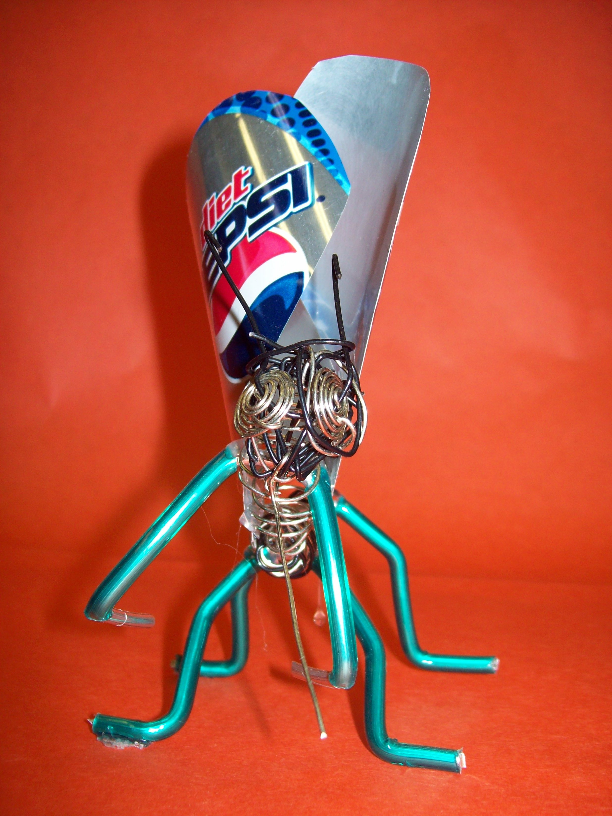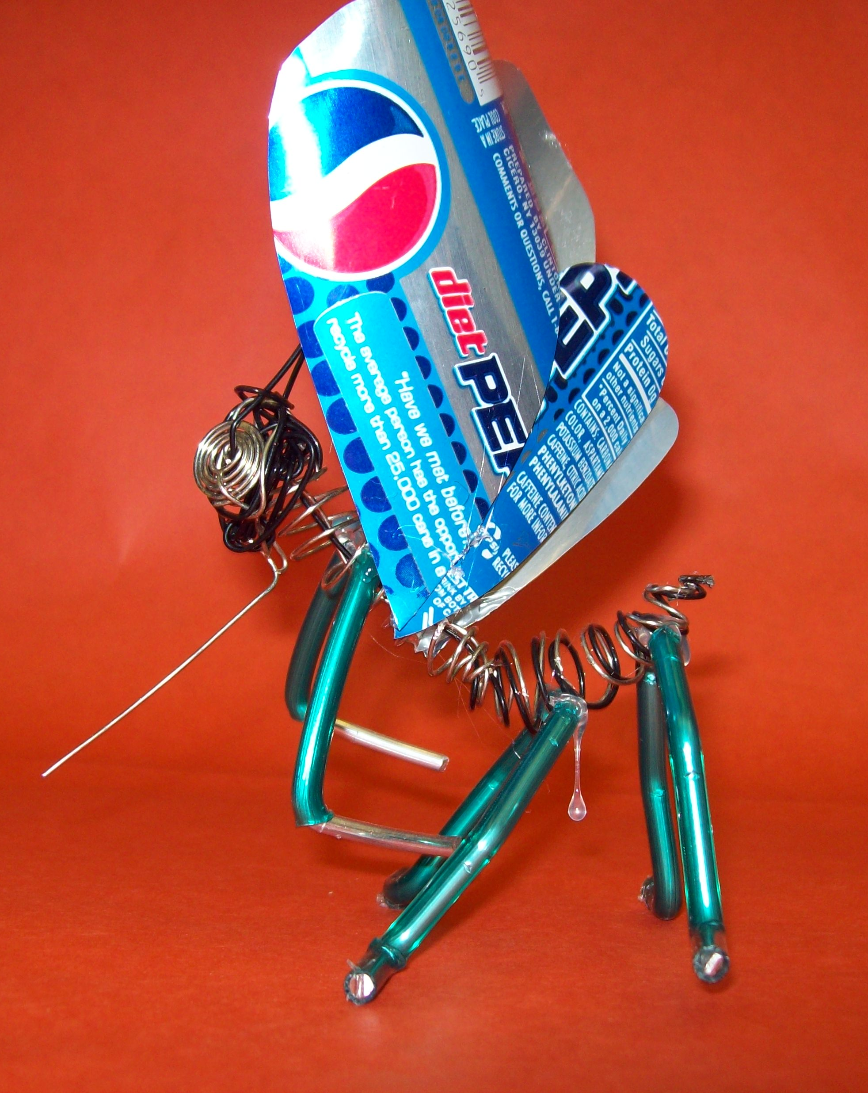

Smith Bug1.jpg Smith Bug 2.jpg

* It is important that you take pictures throughout the semester so that you are not scrambling to get this done at the end of the year.

